Proofreading Marks
In margin | In text | Explanation
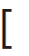 | 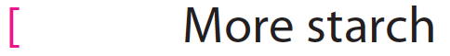 | Left-align text
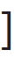 | 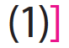 | Right-align text
 | 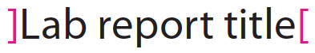 | Center text
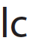 | 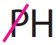 | Use lowercase letter
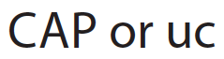 | 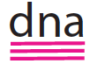 | Use capital (uppercase) letter
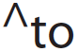 | 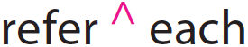 | Insert text
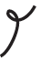 | 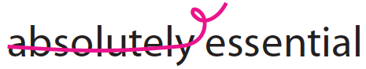 | Delete text
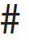 | 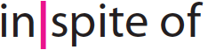 | Insert space
 | 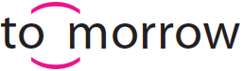 | Close up
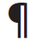 | 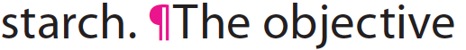 | Start a new paragraph
 | 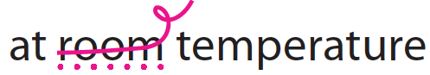 | A dotted underline means “stet,” or “let original text stand.” The correction was made in error.
 | 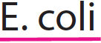 | Italicize Latin names of organisms
 | 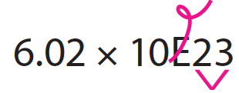 | Delete E and superscript exponent
 |  | Subscript needed

Abbreviations for comments made on lab reports
Abbreviation | Explanation
abbr | Write out the abbreviation the first time it is used, e.g. wild type (WT).
agr | Make subject and verb agree.
awk/incomplete | Revise to make less awkward. Convert sentence fragment to a complete sentence.
bkgd | Background is insufficient. Add details.
calc guid | Use full sentences to guide the reader through the calculation procedure. Use past tense (because the procedure was done in the past) and passive voice (to emphasize what was done, not who did it). For example, The ___ was calculated using ___. Show the original equation and define the terms. Then substitute known (or measured) values and solve for the unknown. State the final answer and include units.
caption pos | Figure caption goes below the figure. Table caption goes above the table. When you make the figure in Excel, leave the "Chart title" space blank.
cit form N-Y | - For 2 authors, include both authors’ surnames separated by and followed by year of publication.  - For 3 authors, include first author’s surname followed by and others and year of publication
cit form | Use CSE Name-Year, Citation-Sequence, or Citation-Name format. See Chapter 4 for specific examples. Do not use direct quotations. Paraphrase and cite the source.
cit missing | Cite all end references in the text.
command | Do not use command style. Reword in past tense. For example, rather than Substitute the absorbance for y and solve for x, write The absorbance was substituted for y, and the equation was rearranged to solve for x.
compare | - Compare treatment and control groups.  - Compare your results with those in journal article.
content | Section is missing essential content
details | - The title is not descriptive. Add details such as variables and organism(s).  - Essential details are missing in the Materials and Methods section. Provide enough detail to enable a trained person to repeat the experiment.
don’t preview | In the Materials and Methods section, do not give a "preview" of how data will be plotted or tabulated in the Results section.
eq ed | Use Equation Editor in Word to make professional-looking equations.  See Appendix 1.
Expl | Explanation is insufficient.
fig format | Figure format is incorrect. See Appendix 2 to format graphs in Excel.  - Use CSE-preferred symbols: filled or open circles, squares, and triangles.  - Make all lines and symbols black for best contrast.  - Use outside tick marks.  - On the axis label, put units in parentheses after the variable.  - Use standard intervals in multiples of 2 or 5 on the axes.  - Shorten axis to eliminate empty space.  - Legend is not needed when there is only one data set.  - Legend is needed to distinguish multiple data sets on one graph.  - Move legend inside axes.  - Make legend entries meaningful. See “More than one data set” in Section A2.4 of Appendix 2.  - Insert a line to show the trend. See “Choose a line” in Section A2.4 to decide which type of line.  - If gridlines are used on bar graphs, make them unobtrusive.  - Delete chart border.
fig/tab pos | Position the figure/table immediately after the text where it is first described. That way readers will read the description first and know what to expect when they see the data.
fig/tab ref | Reference figure/table number in parentheses at the end of the sentence. Put the period after the closing parenthesis.
fig/tab title | - Figure/table title is factually incorrect.  - Figure/table title is inadequate. Add details to make title self-explanatory.  - Use sentence case (do not capitalize common nouns unless they start a sentence).
gram | Grammatical error
head-body sep | Keep section heading and body together.  Windows: On the ribbon, Home | Paragraph diagonal arrow | Line and Page Breaks tab. Check the Keep with next checkbox.  Mac: On the menu bar, Format | Paragraph | Line and Page Breaks. Check the Keep with next checkbox.
heading | Add section heading.
hyp | State the hypothesis.
interp | Interpret the results in the Discussion (not the Results) section.
math | Calculation error
meaning | Make sentences meaningful.
not a recipe | Do not list materials separately. Do not make a numbered or bulleted list. Use full sentences, paragraphs, and past tense to describe the procedure.
num format | - Put a zero in the ones place: 0.1 mL not .1 mL  - Use scientific notation when numbers are very large or very small.
obj? | State the objective(s) of the current study.
page break | End the current page; move subsequent text to next page.  Windows: Ctrl+Enter  Mac: +Enter
¶ | Break this section into paragraphs. When you start a new topic, start a new paragraph.
passive voice | Passive voice is preferred. Shift the emphasis from yourself to the subject of the action.
past tense | - Use past tense to state the objectives.  - Use past tense to describe the procedure.  - Use past tense to indicate that you are referring to your own results and not making a statement that is universally true.
present tense | Use present tense for scientific fact (information already accepted by the scientific community).
punc | Punctuation error
ref missing | List all in-text references in the References section.
ref format | Reference elements are out of order. Information is missing.
rep | Eliminate repetition.
result? | - Describe the result, and reference the figure or table where the data are located.  - Use specific language. How did the independent variable affect the dependent variable? What was the general relationship or trend?
round up | Round up final answer. The final answer cannot be more precise than the least precise measured value.
routine | Do not describe routine laboratory procedures in detail.
run-on | Break run-on sentence into two sentences.
scatter not line | Choose "XY Scatter" not "Line" in Excel to space data correctly. See Section A2.4 in Appendix 2.
source? | Cite sources to provide background information, to substantiate claims, and to compare findings.
sp | Word is misspelled
sub/super | - Superscript exponents.  - Use AutoCorrect to format expressions with sub/superscripts automatically. See Appendix 1.
symbol | Choose the correct symbol from Insert | Symbol on the Ribbon. For example, insert °C instead of writing out degrees Celsius. See Section A1.11 in Appendix 1 to define hot keys.
tab unnec | Do not include a table when the graph shows the same data.
units | Units are missing or incorrect.
unnec intro | Do not write unnecessary introductory phrases like this. See Section 5.4.
wc | Word choice. This word does not fit the context. See Section 7.2, “Choose your words carefully.”
wordy | Revise to reduce wordiness.

