FAPP 9e Writing Projects – Chapter 6

1. Choose two variables that you think have a roughly straight-line relationship. Gather data on these variables and do a statistical analysis: Make a scatterplot, find the correlation, find the regression line (use a statistical calculator or software), and draw the line on your plot. Then write a short report on your work. Some examples of suitable pairs of variables are:
(a) The height and arm span of a group of people
(b) The height and walking stride length of a group of people
(c) The price per ounce and bottle size in ounces for several brands of shampoo and several bottle sizes for each brand

2. Can regression help protect voting rights? This example is adapted from FAPP author Lawrence Lesser's work as a statistician for the Texas Legislative Council. To comply with the Voting Rights Act, a state cannot redraw its districts in a way that dilutes the voting strength of a protected group. Because we cannot know how individuals voted, we cannot directly measure if minority and majority persons tend to prefer different candidates. While there are technical details and assumptions we cannot fully discuss here, you can begin to understand how this might be estimated by exploring the following dataset for nine equal-sized districts, where X is the percent of voters who are Hispanic and Y is the percent of voters that voted for the candidate preferred by most Hispanics:

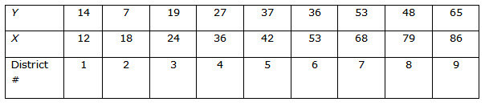

(a) Produce a scatterplot, correlation value, and regression equation. Describe the relationship between the concentration of Hispanic population and the proportion of votes that went to the Hispanic-preferred candidate.
(b) Give a practical interpretation of the value of the slope coefficient. Give a practical interpretation of the value of Y that would be predicted when X = 0 and when X = 100.

