FAPP 9e Writing Projects – Chapter 9

1. In the 2000 presidential election in Florida, the final results were as follows:

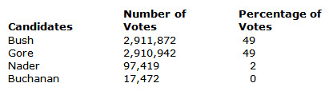

Making reasonable assumptions about voters' preference schedules, give a one-page discussion of how the election might have turned out under the different voting methods discussed in this chapter.

2. Frequently in presidential campaigns, the winner of the first few primaries is given front-runner status that can lead to the nomination of his or her party. Moreover, there are often several candidates running in early primaries such as New Hampshire. In one page, consider a recent election and discuss how the nominating process might have proceeded through the campaign if approval voting had been used to decide primary winners.

