FAPP 9e Writing Projects – Chapter 18

1. A human infant at birth usually weighs between 5 and 10 lb and has a height (length) between 1 and 2 ft, with the shorter babies having the lesser weight. Considering the weight and height of an adult human, write a paragraph arguing that human growth must not be just proportional growth.

2. The principle that area scales with the square of length, and volume with the cube, has important consequences for the depiction and interpretation of data in graphic form. Suppose that we wish to indicate in an artistic way that the weekly income of a U.S. carpenter is twice that of a carpenter in (mythical) Rotundia. We draw one moneybag for the Rotundian and another one "twice as large" for the American. (Illustration from Darrell Huff, How to Lie with Statistics, Norton, New York, 1954, p. 69.)

What's the problem? Well, first, people tend to respond to graphics by comparing areas. Because the larger moneybag is twice as high and twice as wide as the smaller one, its image has four times the area. Second, we are used to interpreting depth and perspective in drawings in terms of three-dimensional objects. Because the larger bag is also twice as thick as the smaller, it has eight times the volume. The graphic leaves the subconscious impression that the U.S. carpenter earns eight times as much, instead of twice as much. With these ideas in mind, evaluate—in a paragraph each—the following data depictions.

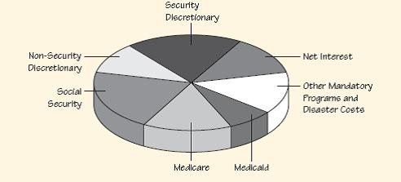

(a) U.S. Federal Budget Policy Outlays by Category for 2015. (U.S. Federal Budget for 2011.) Source: http://www.whitehouse.gov/sites/default/files/omb/budget/fy2011/assets/tables.pdf, p. 153. This display shows expected expenditures of the federal government in 2015, totaling $4.4 trillion (including an anticipated deficit of almost $1 trillion). The actual percentages of expenditure are:

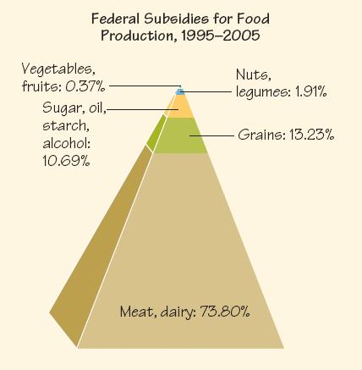

(b) Federal subsidies for food production, 1995 – 2005. ("Why That Salad Costs More Than a Big Mac," Readers Digest, October 2010, p. 72.)

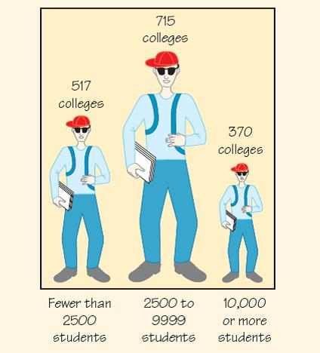

(c) U.S. colleges as classified by enrollment. (From David S. Moore, Statistics: Concepts and Controversies, 4th ed., W. H. Freeman, New York, 1997, p. 217.)

3. Evaluate in a paragraph each of the following depictions (a–c).

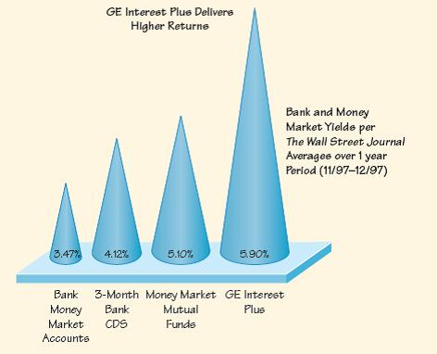

(a) Average bank and money market yields, per the Wall Street Journal, for 1/97 – 12/97. (Source: Flyer from GE Interest Plus.)

(b) Marijuana arrest rates in some California cities, 2006 – 2008. (New York Times, October 23, 2010, p. A19.) (See figure below.)

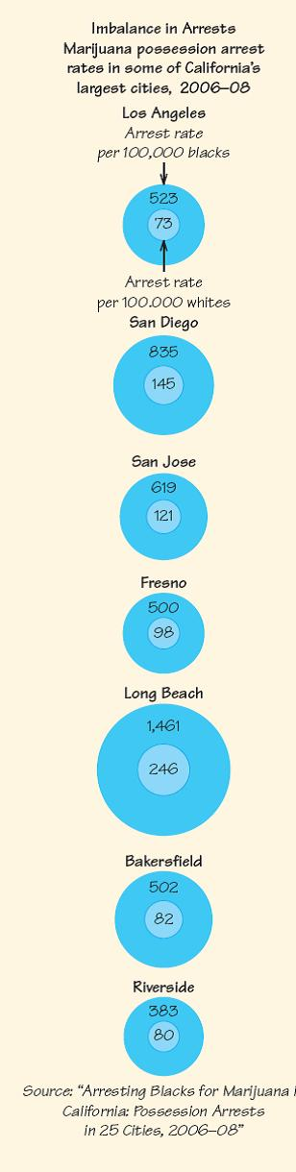

(c) Fuel economy standards for autos. (From Edward R. Tufte, The Visual Display of Quantitative Information, Graphics Press, 1983, p. 57, as adapted from The New York Times, August 9, 1978, p. D2.)

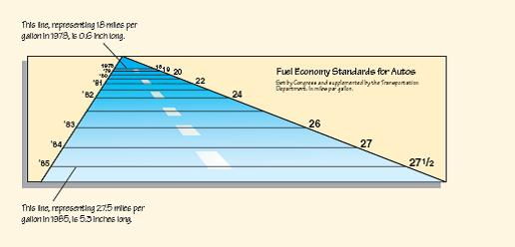

4. With the ideas of Writing Projects 2 and 3 in mind, collect and evaluate similar depictions of data from magazines and newspapers.

5. Dolls and human figures are usually scaled to be geometrically similar to actual humans. But are dolls designed to represent babies or adult humans? Go to a toy store and measure the height, the vertical height of the head, and the arm length of some dolls and other figures. Scale your measurements to compare them with Figure 18.12; from that comparison, try to estimate the ages of the humans that the figures resemble. Write up your procedure, data, calculations, and conclusions in a page or two.

6. (Refer to Exercises 42 – 45.) Because body weight is average density times body volume, BMI is average density times a quantity that has units of length. Discuss whether BMI makes sense as a measure of being overweight. Would dividing by a different power of height make for a better measure? (See Keith Devlin, "Top 10 Reasons Why the BMI Is Bogus," NPR, July 4, 2009, http://www.npr.org/templates/story/story.php?storyId5106268439.)

