ATOMIC THEORY
TEKS 6A

Watch the videos from Dr. Brian Cox “In Search of Giants” http://www.youtube.com/watch?v=bw5TE5o7JtE&list=PLPblR4bWCoxmz2U3YGbNDOVu4cJ4mRteZ

Date | Scientist | Experiment | Claims | Model proposed
1803 | John Dalton | Dalton performed a series of experiments on mixtures of gases to determine what effect properties of the individual gases had on the properties of the mixture as a whole. His exceptional gift for recognizing and interpreting patterns in experimental data lead him from a problem in meteorology to the idea of atoms as fundamental constituents of matter. He realized the vital theoretical connection between atomic weights and weight relations in chemical reactions. He was the first to associate the ancient idea of atoms with stoichiometry. | Dalton's atomic theory makes the following assumptions:  - All matter consists of tiny particles.  - Atoms are indestructible and unchangeable.  - Elements are characterized by the mass of their atoms.  - When elements react, their atoms combine in simple, whole-number ratios.  - When elements react, their atoms sometimes combine in more than one simple, whole-number ratio.
1895 | Wilhelm Roentgen | Roentgen's attention was drawn to a glowing fluorescent screen on a nearby table. Surprisingly, these mysterious rays penetrated the opaque black paper wrapped around the tube. Roentgen had discovered X rays, a momentous event that instantly revolutionized the field of physics and medicine. | Roentgen immediately determined that the fluorescence was caused by invisible rays originating from the partially evacuated glass Hittorf-Crookes tube he was using to study cathode rays (i.e., electrons).
1897 | JJ Thomson | Thomson measured e/m (charge/mass) of electrons | Negatively charged electrons could move around the positively charged sphere. | 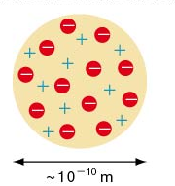
1909 | Robert Millikan | Millikan measured the charge on drops of oil suspended between two metal electrodes. | Determined the charge on an electron to be 1.592 x 10⁻¹⁹ C
1911 | Ernest Rutherford | Rutherford shot alpha particles through thin gold foil onto a fluorescent sheet. While most of the alpha particles passed through without any deflection or change in path, a few bounced back at the source. | The nucleus is small, dense and positively charged with the electrons traveling around the outside. | 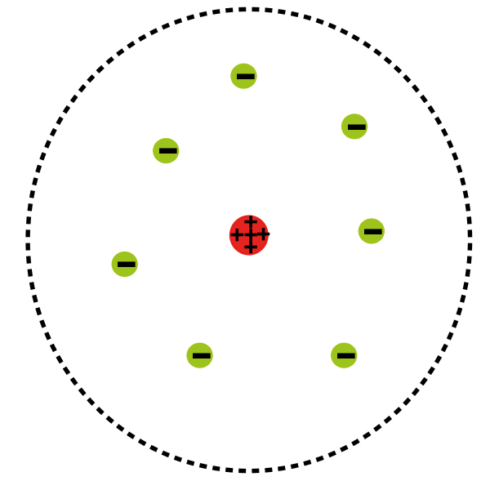
1913 | Neils Bohr | Bohr measured the light emitted from an excited hydrogen atom and developed an equation to explain the phenomena. | Electrons move in discrete paths around the nucleus much like planets around the sun. | 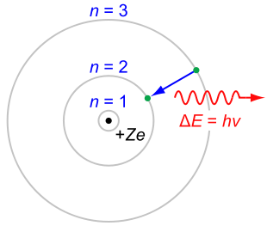

1919 | Francis Aston | Aston developed the first mass spectrograph and determined that different atoms of the same element had different masses. | He identified 212 different isotopes.
1927 | Werner Heisenberg | Credited with the uncertainty principle and therefore the electron cloud model, it may have been Max Born who originally proposed being able to determine the probability of the location of an electron. | The momentum OR the speed of an electron can be measured but not both. Electrons move around a nucleus much like bees around a hive | 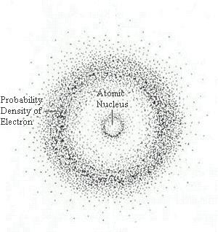
1932 | James Chadwick | Chadwick isolated the neutron and determined its mass. | It is the neutron that is responsible for the isotope. It contributes to the nuclear mass but not to the nuclear charge. He proposed that the neutron was responsible for holding the protons together in the nucleus

