Empirical and Molecular Formulas

A how‐to guide

TEKS 8Cii and 8Ciii

Example 1

A sample of caffeine was found to contain 49.5% carbon, 28.9% nitrogen, 16.5% oxygen and 5.1% hydrogen by mass.

Find the empirical formula for caffeine.

**Step 1 – Mass to moles.** Assume you have a 100 g sample. Convert each element into moles.

carbon: 

hydrogen: 

nitrogen: 

oxygen: 

**Step 2 ‐ relative moles.** Divide the number of moles of each element by the smallest value for moles calculated in step 1.

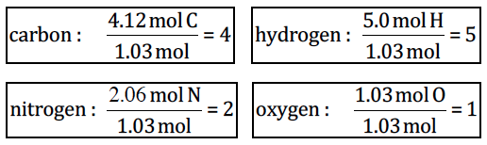

Empirical Formula: C4H5N2O

Molecular Formula

If the molar mass of caffeine is 194.2 g/mol, what is the molecular formula?

Determine the mass for the empirical formula:

4(12.01g)+5(1.01g)+2(14.01g)+1(16.00g) = 97.11 g

Divide molar mass by empirical mass to determine the multiplying factor:

Molecular Formula: C8H10N4O2

Example 2

Sometimes you don’t get even numbers when you divide to determine the lowest whole number ratio.

A sample of a compound was analyzed and found to contain 6.00 g of carbon and 1.100 g of hydrogen. Find the empirical formula.

**Step 1 – Mass to moles.** Assume you have a 100 g sample. Convert each element into moles.

carbon: 

hydrogen: 

**Step 2 ‐ relative moles.** Divide the number of moles of each element by the smallest value for moles calculated in step 1.

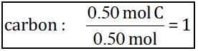 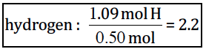

**Step 3 ‐ Make whole numbers**

2.2 is the obvious fraction 2 1/5. So we will multiply the subscripts by 5

Empirical Formula: C5H11

Molecular Formula

If the molar mass is 142.36 g/mol, what is the molecular formula? Determine the mass for the empirical formula:

5(12.01g)+11(1.01g) = 71.16 g

Divide molar mass by empirical mass to determine the multiplying factor:

Molecular Formula: C8H10N4O2