Periodic Table Practice

On the blank periodic table below label and color the following families/groups: transition metals (red); alkali metals (blue); alkaline earth metals (green); halogens (yellow) and noble gases (orange)

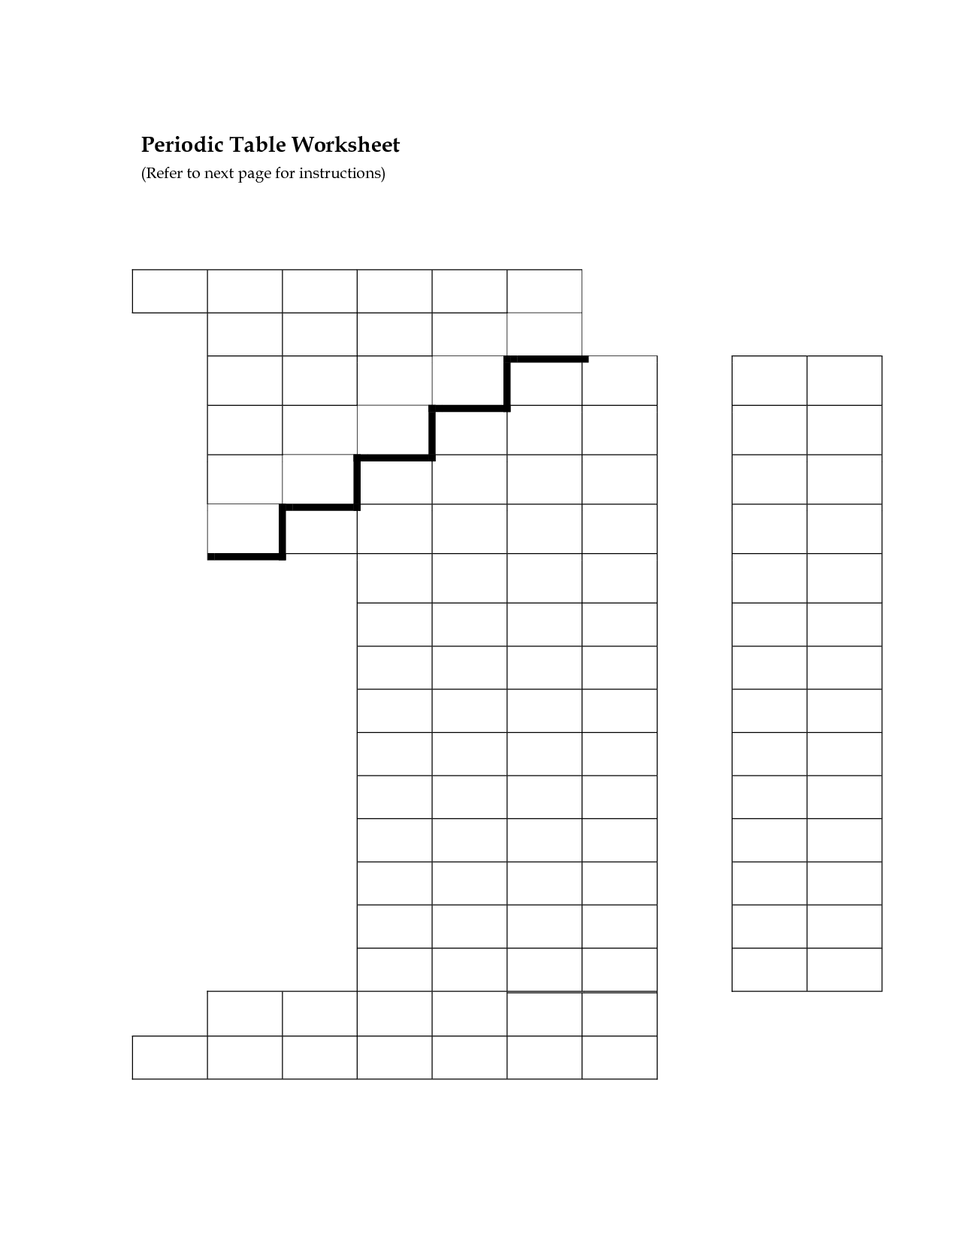

Identify the group on the periodic table with the following properties:
- Are mostly all gases and all diatomic elements

- Soft, lustrous metals that produce hydrogen gas when reacted with water, some violently.

- Also known as the d-block

- Mostly chemically unreactive

- All have 2 valence electrons and are less reactive metals

Describe the trend in both the horizontal and vertical directions on the periodic table for the following properties:

- Atomic radius

- Ionic radius

- Electronegativity

- Ionization energy

Based on valence electrons, explain the trend above.

- Atomic radius

- Ionic radius

- Electronegativity

- Ionization energy

Answers
Periodic Table Practice

On the blank periodic table below label and color the following families/groups: transition metals (red); alkali metals (blue); alkaline earth metals (green); halogens (yellow) and noble gases (orange)
halogens
Alkaline earth metals
Noble gases
Transition metals
Alkali metals

Identify the group on the periodic table with the following properties:
- Are mostly all gases and all diatomic elements -- halogens

- Soft, lustrous metals that produce hydrogen gas when reacted with water, some violently. – alkali metals

- Also known as the d-block transition metals

- Mostly chemically unreactive noble gases

- All have 2 valence electrons and are less reactive metals alkaline earth metals

Describe the trend in both the horizontal and vertical directions on the periodic table for the following properties:

- Atomic radius -- increases as you move down a group; decreases from left to right

- Ionic radius -- Increases as you move down a group; for metals decreases from left to right and for nonmetals increases from left to right

- Electronegativity -- Decreases as you move down a group; increases as you move from left to right

- Ionization energy -- decreases as you move down a group; increases from left to right

Based on valence electrons, explain the trend above.
Atomic radius -- Atomic radius is the measure of the distance from the center of the nucleus to the outer most electron shell. As you move down the periodic table the number of shells increases and thus the atomic radius is larger. Thus, as you move down a group on the periodic table, the atomic radius increases.
As you move from left to right the number of electrons in the outer shell increases. As the number of electrons increase, the effective negative charge in the outer shell increases. As the negative charge increases, the outer shell is attracted to the positive nucleus more and thus the radius decreases in size. Therefore, as you move from left to right on the periodic table, the atomic radius decreases.

Ionic radius -- Ionic radius is the measure of the distance from the center of the nucleus to the outer most electron shell in the ion. As you move down the periodic table the number of shells increases and thus the ionic radius is larger. Thus, as you move down a group on the periodic table, the ionic radius increases.
When you move from right to left for ions you must consider whether you have a metal or nonmetal. As you move from left to right for metals, the metal becomes a cation, thus losing electrons. As you lose electrons, the radius becomes smaller. For nonmetals, as you move from left to right you add electrons. As you add electrons, there is more negative charge than positive charge and the shell expands thus increasing the ionic radius as you move from left to right.

Electronegativity -- Electronegativity is the ability of an atom to attract electrons. As you move down the groups in the periodic table, the outer electrons are farther away from the nucleus and thus there is not as great an attraction. Therefore, electronegativity decreases as you move down the periodic table. As you move from left to right, the more electrons are added to the outer shell and thus there is a higher attraction to the positive nucleus. Thus, electronegativity increases from left to right. Fluorine is the most electronegative element.

Ionization energy -- Ionization energy is the energy required to remove one electron from the outer shell of an atom. As you move down a group on the periodic table, the electrons get farther away from the nucleus an there is less of an attractive force. Thus it requires less energy to remove the electron and the ionization energy decreases as you go down the periodic table.
As you move from left to right an additional electron is added to the outer shell. Since an octet is energetically favorable, as you add electrons, they require more energy to remove and thus the ionization energy increases from left to right

