Honors Chemistry Name
λ, f and E
Date Block

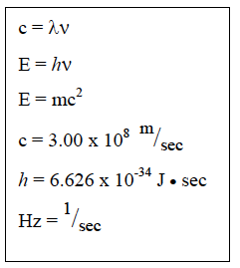
In the space provided show all work. Show the equation used with the variable isolated prior to doing any substitution, Each number should include appropriate units. Write the calculator answer and the final answer rounded to the appropriate number of significant digits.

1. A certain photon of light has a wavelength of 422 nm. What is the frequency of the light?

2. What is the energy of a quantum of light from question 1.

3. What is the energy of a quantum of light with a frequency of 7.39 x 10¹⁴ Hz?

4. What is the wavelength of the quantum of light in question 3?

5. The energy for a quantum of light is 2.84 x 10^{–19} J. What is the wavelength of this light?

6. A certain red light has a wavelength of 680 nm. What is the frequency of the light?

7. What is the energy of a quantum of light from question 7?

8. A certain blue light has a frequency of 6.91 x 10¹⁴ Hz. What is the wavelength of the light?

9. What is the energy of a quantum of light from question 9?

