**Molecular Geometries of Covalent Molecules: Lewis Structures and the VSEPR Model**

TEKS 7Di and 7E

**Preparing to Investigate**

**Types of Bonding Interactions**

Whenever atoms or ions are strongly attached to one another, there is a *chemical bond* between them. There are three types of chemical bonds: ionic, covalent, and metallic. The term *ionic bond* refers to electrostatic forces that exist between ions of opposite charge. You may recall that ions are formed by the transfer of one or more electrons from an atom with a low ionization energy to an atom with a high electron affinity. Thus, ionic substances generally result from the interaction of metals on the far left side of the periodic table with nonmetals on the far right side of the periodic table (excluding the noble gases, group 8A). A *covalent bond* results from the sharing of electrons between two atoms. The most common examples of covalent bonding are found when nonmetallic elements interact with one another. In this investigation you will develop models that represent the geometric shapes of molecules and ions resulting from covalent bonding among various numbers of elements and two of the consequences of geometric structure-isomers and polarity. *Metallic bonds* are found in metals such as gold, iron, and magnesium. In the metals, each atom is bonded to several neighboring atoms. The bonding electrons are relatively free to move throughout the three-dimensional structure of the metal. Metallic bonds give rise to such typical metallic properties as high electrical and thermal conductivity and luster.

**Lewis Symbols**

*Valence electrons* are the outer-most electrons in the incomplete outer shell of an atom. G. N. Lewis proposed a simple and efficient way of showing these valence electrons, which are now called Lewis electron-dot symbols, or simply Lewis symbols. The **Lewis symbol** for an element consists of the chemical abbreviation for the element and a dot for each valence electron. For example, oxygen has the electron configuration [*He*]2*s*22*p*4; therefore, its Lewis symbol shows six valence electrons. The dots are placed on the four sides of the atomic abbreviation.

Each side can accommodate up to two electrons. All four sides are equivalent; the placement of two electrons versus one electron is arbitrary. The number of valence electrons of any representative element is the same as the group number of the element in the periodic table.

**The Octet Rule**

Atoms often gain, lose, or share electrons to achieve the same number of electrons as the noble gas closest to them in the periodic table. Because all noble gases (except He) have eight valence electrons, many atoms undergoing reactions also end up with eight valence electrons. This observation has led to the **octet rule**: *Atoms tend to gain, lose, or share electrons until they are surrounded by eight valence electrons*. An octet of electrons consists of full *s* and *p* subshells on an atom. In terms of Lewis symbols, an octet can be thought of as four pairs of valence electrons arranged around the atom, as in the configuration for Ne, which is . . There are many exceptions to the octet rule, but it provides a useful framework for many important concepts of bonding.

**Covalent Bonding**

Ionic substances have several characteristic properties. They are usually brittle, have high melting points, and are crystalline solids with well-formed faces that can often be cleaved along smooth, flat surfaces. These characteristics result from electrostatic forces that maintain the ions in a rigid, well-defined, three-dimensional arrangement.

The vast majority of chemical substances do not have the characteristics of ionic materials. Most of the substances with which you come in daily contact, such as water, nitrogen, oxygen, and sugar, tend to be liquids, gases, or low-melting solids. Many of them, such as gasoline, vaporize readily. Many are pliable in their solid form.

For the very large class of substances that do not behave like ionic substances, a different model is needed for the bonding between atoms. Lewis proposed that atoms might acquire a noble gas electron configuration by sharing electrons with other atoms to form *covalent bonds*. The hydrogen molecule, H2, provides the simplest example of a covalent bond. When two hydrogen atoms are close to each other, electrostatic interactions occur between them. The two positively charged nuclei and the two negatively charged electrons repel each other, whereas the nuclei and electrons attract each other. The attraction between the nuclei and the electrons cause electron density to concentrate between the nuclei. As a result, the overall electrostatic interactions are attractive in nature.

In essence, the shared pair of electrons in any covalent bond acts as a kind of "glue" to bind the two hydrogen atoms together in the H2 molecule.

**Lewis Structures**

The formation of covalent bonds can be represented using shown below for H2. Lewis symbols as



The formation of a bond between two F atoms to give an F2 molecule can be represented in a similar way.

By sharing the bonding electron pair, each fluorine atom acquires eight electrons (an octet) in its valence shell. It thus achieves the noble-gas electron configuration of neon. The structures shown here for H2 and F2 are called *Lewis structures* (or Lewis electron-dot structures). When writing Lewis structures, you usually show each electron pair shared between atoms as a line (to emphasize that it is a bond) and the unshared electron pairs as dots. Writing them this way, the Lewis structures for H2 is shown as:



The number of valence electrons for the nonmetal is the same as the group number. Therefore, you might predict that 7A elements, such as F, would form one covalent bond to achieve an octet; 6A elements, such as O, would form two covalent bonds; 5A elements, such as N, would form three covalent bonds; and 4A elements, such as C, would form four covalent bonds. For example, consider the simple hydrogen compounds of the nonmetals of the second row of the periodic table.



Thus, the Lewis model succeeds in accounting for the compounds of nonmetals, in which covalent bonding predominates.

**Multiple Bonds**

The sharing of a pair of electrons constitutes a single covalent bond, generally referred to simply as a *single bond*. In many molecules, atoms attain complete octets by sharing more than one pair of electrons between them.

When two electron pairs are shared, two lines (representing a double bond) are drawn. A *triple bond* corresponds to the sharing of three pairs of electrons. An example of the triple bond can be seen in the model of N2.



**Drawing Lewis Structures**

Lewis structures are useful in understanding the bonding in many compounds and are frequently used when discussing the properties of molecules. To draw Lewis structures, you follow a regular procedure.

1. *Sum the valence electrons from all atoms.* Use the periodic table as necessary to help determine the number of valence electrons on each atom. For an anion, add an electron to the total for each negative charge. For a cation, subtract an electron for each positive charge.
2. *Write the symbols for the atoms to show which atoms are attached and connect them with a single bond* (a dash representing two electrons). Chemical formulas are often written in the order in which the atoms are connected in the molecule or ion, as in HCN. When a central atom has a group of other atoms bonded to it, the central atom is usually written first, as in CO32- and BF3. In other cases, you may need more information before you can draw the Lewis structure.
3. *Complete the octets of the atoms bonded to the central atom.* (Remember, however, that hydrogen can have only two electrons.)
4. *Place any leftover electrons on the central atom*, eyen if doing so results in more than an octet.
5. *If there are not enough electrons to give the central atom an octet, try multiple bonds.* Use one or more of the unshared pairs of electrons on the atoms bonded to the central atom to form double or triple bonds.

**Formal Charge**

When drawing a Lewis structure, you are describing how the electrons are distributed in a molecule (or ion) (Section 8.5). In some instances, you can draw several different Lewis structures that obey the octet rule. How do you decide which one is most reasonable? One approach is to do some "bookkeeping" of the valence electrons to determine the *formal* charge of each atom in each Lewis structure. The formal charge of an atom is the charge that an atom in a molecule or ion would have if all atoms had the same electronegativity. To calculate the formal charge on any atom in a Lewis structure, you assign the electrons to the atoms as follows:

1. All of the unshared (nonbonding) electrons are assigned to the atom on which they are found.
2. Half of the bonding electrons are assigned to each atom in the bond.
3. The formal charge of each atom is calculated by subtracting the number of electrons assigned to the atom from the number of valence electrons in the neutral atom.
4. All formal charges should be reasonable (zero formal charges are preferred; otherwise, more electronegative atoms should have negative formal charges).

**EXAMPLE 1**

Draw the Lewis structures for SCN–. Calculate formal charges and designate the preferred structure.

**SOLUTION**: The total number of valence electrons is 6(5) + 4(C) + 5(N) + 1 (minus charge) = 16 electrons. Following are three possible Lewis structures:



The formal charges for structure I are calculated as follows: For the S atom, there are six nonbonding electrons and one bonding electron for a total of seven. The number of valence electrons on a neutral S atom is six. Thus, the formal charge is 6 – 7 = –1. For C, there are four bonding electrons and four valence electrons on a neutral C atom. Thus, the formal charge is 4 – 4 = 0. For N, there are two nonbonding electrons 6  ½ = 3 bonding electrons, and five valence electrons on a neutral N atom. Thus, the formal charge is 5 - 5 = 0. All of the atoms have octets in each structure. Because nitrogen is more electronegative than sulfur is, structure II is preferred on the basis of formal charges. Structure III is not favored because of the large charge separation.

**Bond Polarity and Dipole Moments**

A covalent bond between two different kinds of atoms is usually a polar bond. This is because the two different atoms have different electronegativities, which means that the electrons in the bond are not shared equally by the two bound atoms. This creates a bond dipole moment, μ, which is a charge separation, *Q,* over a distance, *r*:

μ*= Qr*

The bonding electrons have an increased attraction to the more electronegative atom, thus creating an excess of electron density (δ–) near it and a deficiency of electron density (δ+) near the less electronegative atom. You symbolize the bond dipole (a vector) with an arrow and a cross,, with the point of the arrow representing the negative end of the dipole and the cross representing the positive end of the dipole. Thus, in the polar covalent molecule H––Cl, because chlorine is more electronegative than hydrogen, the bond dipole is as illustrated below.

The bond dipole is a vector (has magnitude and direction), and the dipole moments of polyatomic molecules are the vector sums of the individual bond dipoles as illustrated in Figure 3.1.

Because H2O has a molecular dipole and CCl4 does not, H2O is a polar molecule and CCl4 is a nonpolar molecule.

**The VSEPR Model**

In covalent molecules, atoms are bonded together by sharing pairs of valence-shell electrons (Section 9.2). Electron pairs repel one another and try to stay out of each other's way. *The best arrangement of a given number of electron pairs is the one that minimizes the repulsions among them.* This simple idea is the basis of valence shell electron pair repulsion, or the **VSEPR** model. Thus, as illustrated in Table 3.1, two electron pairs are arranged *linearly*, three pairs are arranged in a *trigonal planar* fashion, four are arranged *tetrahedrally*, five are arranged in a *trigonal bipyramidal* geometry, and six are arranged *octahedrally*. The shape of a molecule or ion can be related to these five basic arrangements of electron pairs.

**Predicting Molecular Geometries** When drawing Lewis structures, you encounter two types of valence shell electron pairs: **bonding pairs**, which are shared by atoms in bonds, and nonbonding pairs (*or lone pairs*), as in the Lewis structure for NH3.

Because there are four electron pairs around the N atom, the electron-pair repulsions will be minimized when the electron pairs point toward the vertices of a tetrahedron (see Table 3.1). The arrangement of electron pairs about the central atom of an AB*n* molecule, where A is the central atom and B are the peripheral atoms, is called its **electron-domain geometry**. However, when using experiments to determine the structure of a molecule, you locate atoms, not electron pairs. The **molecular geometry** of a molecule (or ion) is the arrangement of the *atoms* in space. You can predict the molecular geometry of a molecule from its electron-domain geometry. In NH3, the three bonding pairs point toward three vertices of a tetrahedron. Therefore, the hydrogen atoms are located at the three vertices of a tetrahedron and the lone pair is located at a fourth vertex. The arrangement of the atoms in NH3 is thus a *trigonal pyramid*; the sequence of steps to arrive at this prediction are illustrated in Figure 3.2. It shows that the trigonal-pyramidal molecular geometry of NH3 is a consequence of its tetrahedral electron-domain geometry. When describing the shapes of molecules, you give the molecular geometry rather than the electron-domain geometry.

Following are the steps used to predict molecular geometries with the VSEPR model:

1. Sketch the Lewis structure of the molecule or ion.
2. Count the total number of electron pairs around the central atom and arrange them in a way that minimizes electron-pair repulsions (see Table 3.1).
3. Describe the molecular geometry in terms of the angular arrangement of the bonding pairs, which corresponds to the arrangement of bound atoms.

Application of the VSEPR model to molecules that contain multiple bonds reveals that a double or triple bond has essentially the same effect on bond angles as does a single bond. This observation leads to a fourth rule:

1. A double or triple bond is counted as one bonding pair in predicting geometry.

This table summarizes the predicted molecular geometry when using VSEPR model.

(SN is steric number)

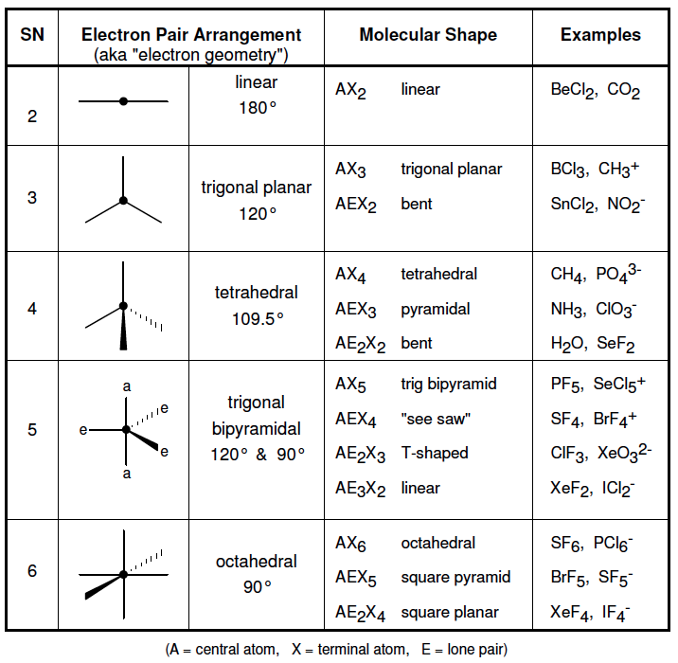

**Valence Bond (VB) Theory: Covalent Bonding and Orbital Overlap**

Although the VSEPR model provides a simple means for predicting molecular shapes, it does not explain why bonds exist between atoms. In 1931, Linus Pauling developed a bonding model called valence bond theory, based on the marriage of Lewis's notion of electron-pair bonds to the idea of atomic orbitals (section 9.4). By extending this approach to include the ways in which atomic orbitals can mix with one another, a picture appears that corresponds nicely to the VSEPR model.

In the Lewis theory, covalent bonding occurs when atoms share electrons. Such sharing concentrates electron density between the nuclei. In the valence bond theory, the buildup of electron density between two nuclei is visualized as occurring when a valence atomic orbital of one atom merges with that of another atom. The orbitals are then said to share a region of space, or to overlap. The overlap of orbitals allows two electrons of opposite spin to share the common space between the nuclei, forming a covalent bond as shown for the H2, HCl, and Cl2 molecules.

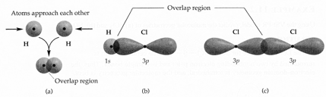

**Hybrid Orbitals**

Although the idea of orbital overlap allows you to understand the formation of covalent bonds, it is not always easy to extend these ideas to polyatomic molecules (Section 9.5). You need to understand both the formation of electron-pair bonds and the observed geometry. Consider the molecule BeF2:

The VSEPR model predicts, correctly, that this molecule is linear. Beryllium has a l*s*22*s*2 electron configuration with no unpaired electrons. Which orbitals on Be overlap with orbitals on F to form bonds? If the electron configuration of Be were promoted to 1*s*2 2*s*1 2*p*1, a Be *s* and a *p* orbital could be used for bonding. You can also answer the question by "mixing" the 2*s* orbital with one of the 2*p* orbitals on Be to generate two new orbitals as shown in Figure 3.4.

Like *p* orbitals, each of the new *sp* orbitals has two lobes. The new orbitals are identical in shape, but their large lobes point in opposite directions. Two **hybrid orbitals** have been created, orbitals formed by mixing two or more atomic orbitals on an atom, a procedure called hybridization.